Early Career Teachers Programme Mentor Conference 2 Workbook

Mentor Conference 2 – session aims
To understand:
- The importance of the second year of the Early Career Teachers Programme
- The similarities and differences of the second year
- Your role as mentor within the programme in year 2
- The importance of self-regulation in teacher expertise
- How teachers get better – a theory of teacher change
- How to adapt instructional coaching as early career teachers develop expertise

Today’s session
Section 1: Year 2: what and why Page 3
Section 2: Science of learning Page 5
Section 3: How teachers get better Page 11
Section 4: Adapting the coaching model Page 12
Section 5: Instructional coaching Page 15
Section 6: Implementation and reflection Page 26
Section 1: Year 2 of the Early Career Framework
Reflection
- Share something from year 1 of the programme which you are proud of
- Share a challenge from year 1 of the programme that you managed to overcome
- Share the aspects of the programme that you and your early career teacher(s) found most helpful

- Which areas of the framework do you feel that your ECT(s) has developed a strong level of understanding of?
- Which elements might they need further support or practice to master?

Check for understanding
Which of these statements about year 2 are true?
- Mentors and early career teachers both have funded time to meet.
- Only early career teachers have funded time to meet.
- Early career teachers have already learnt all of the self-study content.
- Early career teachers no longer need instructional coaching.

Section 2: How people learn
Test v Study
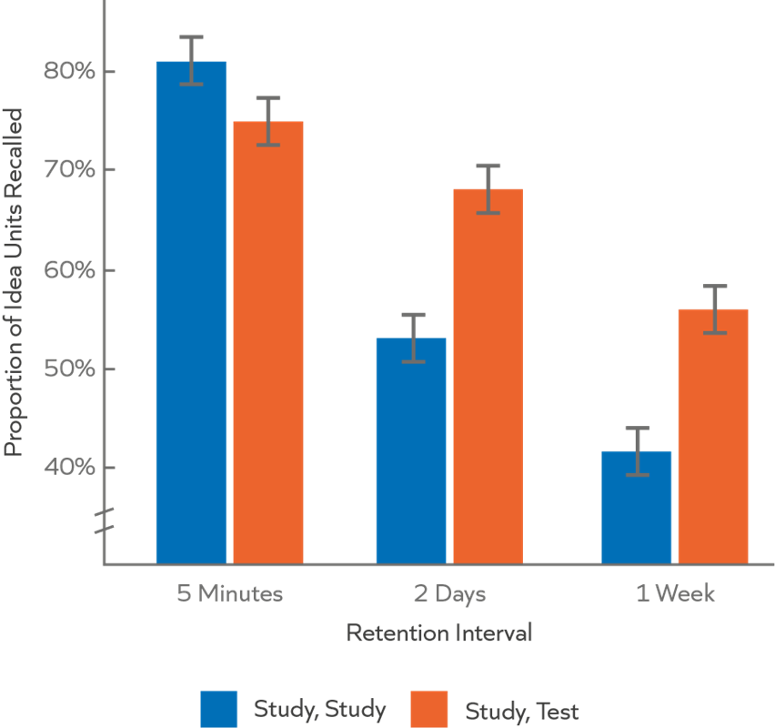
Adapted from: Roediger & Karpicke (2006)
Retrieval practice
- Using the space on the following page, write down an explanation of Willingham’s simple model of memory. Try to include information about:
  - Working memory
  - Long-term memory
  - Implications for teachers
- What is a mental model (schema)?
- Explain how the mental models of novices and experts differ.

See appendix on page 30 for prompts.

Building mental models
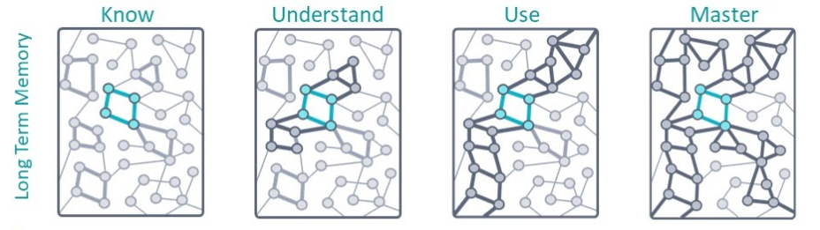
(Furst, 2018, available at: https://sites.google.com/view/efratfurst/learning-in-the-brain)
Space for notes:

Teacher expertise
Expertise as mental models
As teachers move from novice to expert, they develop increasingly powerful mental models in the following broad domains:
Path – Knowledge of the pathway towards mastery of a curriculum, including: the concepts and process that pupils need to know at different stages of their journeys; how these are best represented and sequenced (Hattie, 2003; Westerman, 1991); as well as common obstacles to progress (Sadler, 2016).
Pupil – Knowledge of what their pupils know and don't know, what motivates and concerns them, and how these things change over time (Berliner, 2004, Schempp, 2002). The development of pupil knowledge is produced (and limited) by teacher assessment knowledge (Christodoulou, 2017; Wiliam, 2016).
Pedagogy – Knowledge of how learning works and how to catalyse it. This area draws on fields such as cognitive and behavioural science (Deans for Impact, 2015) as well as personal experience, to help teachers build a mental model of the learner (Willingham, 2017b). It encompasses cognitive, emotional, social and cultural dimensions of learning.
Self-Regulation – Knowledge of how to analyse, evaluate and iterate their own knowledge and action towards increasing impact (Ericsson, 2015; Hattie, 2012). This includes an awareness of their own cognitive biases and how to mitigate them.
Reduce the power of any of these domains and teacher impact declines accordingly.
(Mccrea, 2018)
Check for understanding
Which of the following statements are true?
- Once an idea is in long-term memory, we can recall it easily
- Practising using knowledge or skills in different contexts makes it easier to recall them in the long-term
- Having a more developed mental model of an idea means it is better linked to other ideas so is easier to recall
- Long-term memory appears to be unlimited, so we can remember and recall everything we have learnt
- Once teachers have built expertise in a skill in one context, they will easily be able to apply this to other contexts.

Reflection
Think about one of the teachers you have worked with over the past year.
- Which areas are priorities for further developing their mental models in year 2? You could consider:
  - Areas where they appear to have limited mental models
  - Areas where they appear to have well-developed mental models and require challenge
- How could you use Furst’s ideas about varying practice to support this?

Metacognition
- Cognition: the mental process involved in knowing, understanding and learning.
- Metacognition: the ways learners monitor and purposefully direct their learning.
- Motivation: our willingness to engage our metacognitive and cognitive skills.
(EEF, 2017)

Summary
Summarise what we’ve discussed about metacognition. You might include:
  - What is metacognition?
  - How can we support pupils (and teachers) in developing metacognitive skills?
  - How does metacognition link to Mccrea’s four domains of expert teacher knowledge?

Section 3: Teacher change
Reflection
- Think about something you coached your ECT on earlier this year but that you haven’t returned to. How will you revisit this in year 2?
- How successful were you in embedding habits with your ECT this year? What was effective? What will you change in year 2?
- How do Furst’s ideas about the development of mental models link to the coaching process?

Section 4: Adapting the coaching model
Expertise as action
As people become more expert in a field or topic, they have greater levels of knowledge which are better organised into useful mental models in their long-term memory. These mental models mean that experts display what appears to be intuition but reflects extensive experience which allows them to see and think about problems differently (Berliner, 1988).
Expertise as action
Perception – Expert teachers perceive events at a deeper, more abstract level.
Simulation – Experts more accurately pre-empt consequences of actions as their mental models allow them to predict what the likely outcomes will be and make an effective professional judgement accordingly.
Execution – Experts are more flexible in their decision making and the action they take is the most efficient way of dealing with the problem.
Conservation – Expert teachers have automated many elements of their practice which allows them to focus their attention on the most important parts of teaching.

Teacher perception
“In the lesson I noticed X. What can you tell me about it?”
“What impact did this have on pupil learning?”
What might an ECT’s response to these questions tell you?
Perceive scenario
When observing your ECT as the mentor, you have noticed that pupils ran out of time during a self-assessment task. This is because pupils were slow to start the task because they were given too much time to get their equipment ready.
You want to see if your ECT has noticed the same thing, and whether they can diagnose the issue correctly, so you ask:
“What can you tell me about how pupils self-assessed their work in the lesson?”
The table below contains three possible answers to this question.
- What is each answer telling you about the teacher’s perception?
- In each case, what question would you ask next? Would you need to be more or less directive?
- [Optional stretch question] If you know your teacher will find this hard write a different question which scaffolds them to notice what you want.

Teacher A | “All the pupils used green pens [in line with school policy] to self-assess their work.”
Teacher B | “Some of the pupils ran out of time for the self-assessment.”
Teacher C | “It took some of the pupils quite a long time to start doing the self-assessment, so they ran out of time.”

Section 5: Instructional coaching
Instructional coaching quiz
- Which of the following are active ingredients of instructional coaching?
  - A standardised routine
  - Steplab
  - Bite-sized steps for improvement
  - Time for reflection
  - Choosing the highest leverage action step
  - Clear model of better
  - Deliberate practice
- What are the key elements of deliberate practice?

- Explain how instructional coaching helps build teachers’ mental models.

Case study for examples
Nick is coaching Leah, a teacher at the start of her second year of induction. Leah has made strong progress during her first induction year. Having completed her ITT in the same school she also has considerable knowledge of the school procedures and culture. Although Leah built effective routines for behaviour last year, Nick has decided to revisit the behaviour strand for at least the first half term of the second year. This will provide Leah with support in transferring and adapting her routines to her new class(es), as well as the opportunity to practise some of the skills in modules that were not covered in year 1. Coaching Leah on the same area for a period of time will help Leah to build her sense of self-efficacy in this area; the sense of success will also build her confidence.
So far this term, Leah and Nick have worked on re-establishing routines (B2) and directing pupils’ attention during modelling (B7). Leah’s most recent self-study was B10: Independent practice, which she hadn’t studied in year 1. From talking to Leah and watching her teach this term, Nick had already thought that she might benefit from some support with setting up independent practice. He decided to observe a segment of the lesson where Leah was moving from modelling to independent practice; this would give him a good opportunity to identify whether Leah really did need to work on setting up independent practice next.
In the lesson, Nick noticed that when Leah set pupils going on an independent task, some of them got stuck quickly and couldn’t resolve their problems without Leah’s help. Leah’s instructions for the task and her explanation beforehand were both clear – she was achieving her previous action step of directing pupils’ attention to the key aspects of her model. Leah also checked for understanding using a multiple-choice question. Nick noticed that the pupils who were able to get on with the task were using the worked example on the board and looking back through their notes for support. He decided to look at the development area “Establishing clear expectations for independent practice” and narrows his focus to “Teacher gives pupils strategies to tackle the work if they think they are stuck before resorting to asking the teacher”. He decides to start with the most straightforward action step as he knows he can always add challenge into the practice. Nick chooses the step: “Before pupils do independent work, give them one strategy they should use before asking you for help with tackling the content of the task, e.g. refer to the example on the board.”
The success criteria for the action step are:
- Concrete: ‘Look at the example on the board.’ NOT ‘Think about what I just taught you.’
- Applicable: teacher gives a strategy that will be helpful for pupils across tasks.

Example: Model & analyse
Example – success criteria
Step | Success criteria | Met? (Y/N)
Sharing the action step | The mentor shares the new action step with the teacher and links it to the module.
Delivering the model | Demonstration: The mentor provides a demonstration of the technique/strategy.
 | Authentic: The mentor models as though delivering to the class, without ‘breaking out’ of role.
 | Exposes thinking: The mentor uses a ‘whole-part-whole’ structure: first sharing the whole model, then breaking it down to show the success criteria, then modelling whole action step.
The model itself | All criteria: The model exemplifies all the success criteria for the action step (below).
 | Nothing extra: The model does not contain unnecessary additional information.
 | Concrete: ‘Look at the example on the board.’ NOT ‘Think about what I just taught you.’
 | Applicable: teacher gives a strategy that will be helpful for pupils across tasks.
Analyse | The mentor asks the teacher to use the success criteria to explain what was effective about the model. If needed, tell them what they have missed.
 | The mentor asks the teacher to reflect on the difference between their current practice and the model. If needed, tell them what they have missed.
 | The mentor asks the teacher when else that could use this action step in their practice and why it would be appropriate.
What other questions did the mentor ask?
How were they effective?

Case study for practising
We will use a similar case study to practise, but with a different action step. This time we will consider Shifa who is mentoring Frank, an ECT. Their context is similar to that of Leah and Nick from earlier.
Shifa is coaching Frank, a teacher at the start of his second year of induction. Frank has made strong progress during his first induction year. Having completed his ITT in the same school he also has considerable knowledge of the school procedures and culture. Although Frank built effective routines for behaviour last year, Shifa has decided to revisit the behaviour strand for at least the first half term of the second year. This will provide Frank with support in transferring and adapting his routines to his new class(es), as well as the opportunity to practise some of the skills in modules that were not covered in year 1. Coaching Frank on the same area of teaching for a period of time will help Frank to build his sense of self-efficacy in this area; the sense of success will also build his confidence.
Frank has discussed with Shifa that although he feels that she is successful at getting pupils to follow his instructions, he’d like to get them to do this more quickly, to make better use of the lesson time. This helped Shifa focus on a particular aspect of Frank’s practice when she watched his lesson.
In the lesson, Shifa noticed that when Frank gives instructions, he gets pupils attention successfully and is positioned so he can check they follow his instructions. Shifa agreed with Frank that some pupils are taking longer than they need to, and thinks that module B4: Directing Attention might contain some techniques that Frank might find effective. She thinks that he can utilise the norms he has set in the classroom to push them to do this. She decided to look at the development area “Using positive reinforcement and social norms” and narrows her focus to “Teacher encourages pupils to quickly follow their instructions using repeated positive reinforcement and time limits”. She decides to start with the most complex action step as Frank is already using some positive reinforcement. Shifa chooses the step: “Encourage pupils to follow your instructions quickly by using a time limit in your instructions and quickening the pace of your voice as you reinforce the behaviours you see.”
The success criteria for the action step are:
- Timed: the instructions state the specific actions pupils need to take in an ambitious but achievable time limit.
- Build reinforcement: teacher calls out the behaviour and continues highlighting more and more pupils doing it, e.g. “Jamie has his sheet stuck in... now the front row all do...'
- Quick-fire: the pace of reinforcement quickens as more pupils do the behaviour, highlighting that following instructions is the social norm.
- Measured: teacher shows appreciation for positive behaviour but does not treat it as an accomplishment when it is not, e.g. ‘Front row have their pens moving.’ NOT ‘Fantastic! It is great to see the front row with their pens moving.’

Practise: Model & analyse
Action Step
Encourage pupils to follow your instructions
Planning the model & analyse section
You have up to 5 minutes to plan your model to deliver to your partner and plan the questions you will ask them to support them to analyse the difference between the model and their practise.
Space to plan your model:

Success criteria for your model:
In general:
- Demonstration: The mentor provides a demonstration of the technique/strategy.
- Authentic: The mentor models as though delivering to the class, without ‘breaking out’ of role.
- Exposes thinking: The mentor uses a ‘whole-part-whole’ structure: first sharing the whole model, then breaking it down to show the success criteria, then modelling whole action step.
- All criteria: The model exemplifies all the success criteria for the action step (below).
- Nothing extra: The model does not contain unnecessary additional information.
For this model in particular:
- Timed: the instructions state the specific actions pupils need to take in an ambitious but achievable time limit.
- Build reinforcement: teacher calls out the behaviour and continues highlighting more and more pupils doing it, e.g. “Jamie has his sheet stuck in... now the front row all do...'
- Quick-fire: the pace of reinforcement quickens as more pupils do the behaviour, highlighting that following instructions is the social norm.
- Measured: teacher shows appreciation for positive behaviour but does not treat it as an accomplishment when it is not, e.g. ‘Front row have their pens moving.’ NOT ‘Fantastic! It is great to see the front row with their pens moving.’

The practice tasks on Steplab are:
- Access the resources for an upcoming lesson.
- Script a set of instructions you will need to deliver that lesson and include a time limit, e.g. ‘When I say go, you will pack your equipment in your bags and stand behind your desks silently. Let’s see if we can get it down to 15 seconds.’
- Select a behaviour you expect some pupils will do immediately and others will need some support remembering to do.
- Script statements you will say that would show pupils more and more of them are following your instructions quickly, e.g. ‘Karen and Jason have tucked their chairs under neatly... So has everyone on the front table...'
- Stand up in role to practise delivering the instruction, scanning the class and delivering the quick, positive reinforcement as if the pupils were present.
Space to plan the analyse section of the meeting:
Default prompts:
- Can you use the criteria to explain what was effective about my model?
- What is the difference between my model and your current practice? Use the criteria to help you.
- Where and when might you use this step?

Note to person acting as the teacher, use the case study to guide your answers to the questions.
Practising the model and analyse section
Timing: 10 minutes per round
- 5 minutes: Person one as the mentor shares the action step and the model and leads the analyse conversation with person two as the teacher
- 2 minutes: Person two provides feedback to person one based on the success criteria
- 3 minutes: Person one re-practises the relevant section based on the feedback to improve
- Swap roles
Step  Sharing the action step | Success criteria  You share the new action step with the teacher and link it to the module | Put a tick in this box if the success criteria have been met and a cross if it has not
 |  | Round 1 | Round 2
Delivering the model | Demonstration: You provide a demonstration of the technique/strategy
Delivering the model | Authentic: You model as though delivering to the class, without ‘breaking out’ of role
 | Exposes thinking: You use a ‘whole-part-whole’ structure: first you share the whole model, then break it down to show the success criteria, then model the whole action step.
The model itself | All criteria: The model exemplifies all the success criteria for the action step (below)
 | Nothing extra: The model does not contain unnecessary additional information
 | Timed: the instructions state the specific actions pupils need to take in an ambitious but achievable time limit.
 | Build reinforcement: teacher calls out the behaviour and continues highlighting more and more pupils doing it, e.g. “Jamie has his sheet stuck in... now the front row all do...'
 | Quick-fire: the pace of reinforcement quickens as more pupils do the behaviour, highlighting that following instructions is the social norm.
 | Measured: teacher shows appreciation for positive behaviour but does not treat it as an accomplishment when it is not, e.g. ‘Front row have their pens moving.’ NOT ‘Fantastic! It is great to see the front row with their pens moving.’
What went well –

Next time try –

Example: Practise
Success criteria
Section | Success Criteria | Put a tick in this box if the success criteria has been met and a cross if it has not
Setting up the practise | The mentor explains how the practise will run.
 | The mentor provides the success criteria that they will provide feedback on the basis of.
During the practise | The mentor scaffolds the practise, firstly by asking the teacher to script and read out the script and then asking the teacher to stand up and practise.
 | The mentor provides feedback related to the success criteria and asks the teacher to re-practise.
 | Concrete: ‘Look at the example on the board.’ NOT ‘Think about what I just taught you.’
 | Applicable: teacher gives a strategy that will be helpful for pupils across tasks.
What went well –

Next time try –

Reflection
- How does the mentor use feedback to stretch the ECT?

Practise: Practise
Firstly, you are going to script your instructions. After that I will ask you to read through them and check them against the success criteria. Then I will ask you to deliver them in role as a teacher.
I will then give you feedback based on the success criteria and you will re-practise based on the feedback.
The success criteria are:
- Timed: the instructions state the specific actions pupils need to take in an ambitious but achievable time limit.
- Build reinforcement: teacher calls out the behaviour and continues highlighting more and more pupils doing it, e.g. “Jamie has his sheet stuck in... now the front row all do...'
- Quick-fire: the pace of reinforcement quickens as more pupils do the behaviour, highlighting that following instructions is the social norm.
- Measured: teacher shows appreciation for positive behaviour but does not treat it as an accomplishment when it is not, e.g. ‘Front row have their pens moving.’ NOT ‘Fantastic! It is great to see the front row with their pens moving.’
Frank’s instructions (to be played by the person being the teacher)
When I say go, I want you to pass the sheets backwards down your row. Let’s see if we can get this done in under 15 seconds.
- Person nearest the window takes one sheet, passes the rest to their partner.
- Partner takes one sheet and passes the rest behind them.
- Repeat until everyone has a sheet.
- Keep any spare sheets at the back.
- Go!
Frank will use a countdown and provide reinforcement after giving the instructions.
Space for any edits you wish to the practice

How will you practise?
Tell your partner whether it is most useful for you to focus on stretching a high-performing ECT – if it is then they will attempt to practise to a high standard straight away, if not then they will plan to make mistakes.
Timing: 10 minutes per round
- 6 minutes: Person one will run the practise. For the purpose of the practise when asked by the mentor to write down your instructions, as the teacher, please just say completed, in order to save time (as you will be using the instructions on the previous page).
- 1 minute: Person two will provide feedback based on the success criteria
- 3 minutes: person one will re-practise a relevant section based on the feedback
- Swap roles

Success criteria
Section | Success Criteria | Put a tick in this box if the success criteria has been met and a cross if it has not
 |  | Round 1 | Round 2 | Round 3 | Round 4
Setting up the practise | The mentor explains how the practise will run
 | The mentor provides the success criteria that they will provide feedback on the basis of
During the practise | The mentor scaffolds the practise, firstly by asking the teacher to script and read out the script and then asking the teacher to stand up and practise
 | The mentor provides feedback related to the success criteria and asks the teacher to re-practise
 | Timed: the instructions state the specific actions pupils need to take in an ambitious but achievable time limit.
 | Build reinforcement: teacher calls out the behaviour and continues highlighting more and more pupils doing it, e.g. “Jamie has his sheet stuck in... now the front row all do...'
 | Quick-fire: the pace of reinforcement quickens as more pupils do the behaviour, highlighting that following instructions is the social norm.
 | Measured: teacher shows appreciation for positive behaviour but does not treat it as an accomplishment when it is not, e.g. ‘Front row have their pens moving.’ NOT ‘Fantastic! It is great to see the front row with their pens moving.’
What went well –

Next time try –

Section 6: Implementation
Preparing for year 2
Dos: | Don’ts:
- Do make sure that you and your ECT(s) have timetabled time to meet. Remember that the funding covers a 5% reduction in timetable for early career teachers, and time for mentors to meet with teachers. | - Don’t cram in additional self-study or coaching sessions in the summer term this academic year. There is no need to ‘finish’ the content in Year 1. In fact, this is likely to be actively unhelpful. All the content will continue to be available in Year 2.
- Do spend time reflecting on the first year of the programme, individually and together. What went well? Did you effectively build habits? What would you do differently? | - Don’t spend time ‘collecting evidence’ for the content within the ECF. The ECF is an entitlement to support and is not linked to assessment for passing induction.

Enabling conditions
- Mentor/teacher relationship
- Time
- Leadership support
- School culture
- ECT subject/phase knowledge
- Effective habits and routines for coaching (and ECT study)
(Re-)contracting
- Did you use the contracting process to set up your ways of working in September? Did you recontract at any point during the year?
- How did addressing the contracting questions (below) in advance set the relationship up effectively?
  - What do you want from this relationship?
  - Where might you need help?
  - When you had a really good working relationship in the past, what happened?
  - When things go wrong, what does that look like on your end? How do you behave?
  - When things go wrong - as they inevitably will- how shall we manage that?
- If you didn’t make use of the contracting structure, what did you do to successfully build a relationship with your teacher?
- Whether you used the contracting structure or not, is there anything you would do differently, or plan to address at the start of the second year?

Reflection on year 1: habits
- How did you successfully embed habits – both in terms of routines around coaching and your ECT’s practice?
- Are there any habits you want to embed further?
- Are there any specific classroom habits (e.g. asking “does that make sense?” instead of checking for understanding) you might want to support your ECT to change?

Enabling conditions: review
What might your next steps be in order to ensure that the enabling conditions are in place in school?
 | Definitely in place? | If not, action needed?
Has time been protected for you and your ECT to meet at least fortnightly?
Is this on both your timetables?
Is support for ECTs prioritised by school leadership?
Is regular coaching already a well-developed habit? If not, what are your next steps towards embedding it as a habit? For you? For your ECT?
Are you aware of any additional support your ECT is likely to need, such as additional subject knowledge support?
Any other reflections

Discussion
- What areas of classroom practice is your ECT(s) likely to be able to take greater ownership of in year 2?
- What areas are they still likely to need a greater degree of scaffolding and support?
- How might you help them choose a focus to start year 2 that allows them to feel successful?

Action-planning for year 2
- When are where will you meet for coaching?
- What areas of the programme will your ECT(s) need to revisit or address gaps in their knowledge?
- What might your focus with your ECT be in September?
What | When | Where | Notes
Example:  Fortnightly coaching meeting | Wednesday 3:30pm  (will use timetabled reduction for other tasks) | Sean (ECT)’s classroom
Example:  Revisit routines, consistency and instructions | Half-term 1 | N/A | Sean needs to re-establish himself with new pupils
- What are your key takeaways from today’s session?

Appendix
Support for retrieval practice on page 5
Simple Memory Model
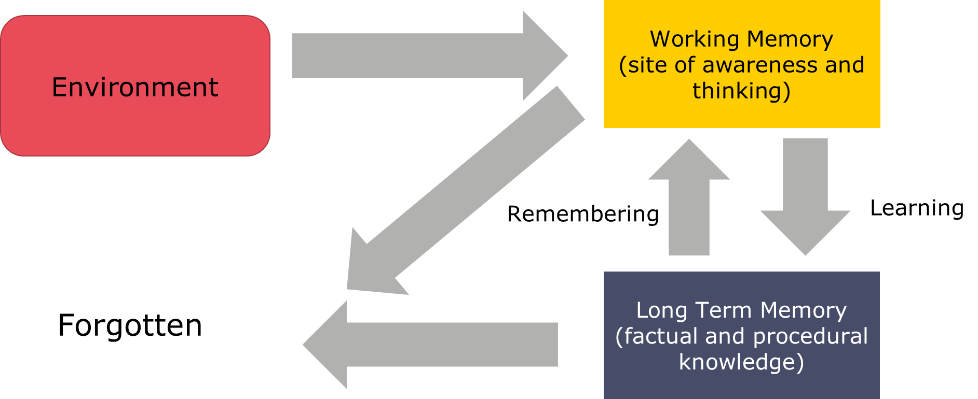
(Willingham, 2009)

- Working memory is limited (4-5 items).
- Long-term memory appears to be limitless.

Mental models
- Mental models are the knowledge you have and how that knowledge is organised.
- Expertise is domain specific.
- Novices have simple mental models, focused on surface level features.
- Experts have extensive mental models with knowledge grouped and organised according to its deep structures.
Mentor curriculum
When | What | Content
June/July | - Pre-conference learning  - Mentor conference 2 | - Introduction to year 2 of the programme
Year 2 | - (Re-)contracting with your ECT  - (Re-)start instructional coaching  - Mentor clinic (3 of 3)  - Coaching on coaching (3 of 3) | - Deliberate practice: action steps  - 1:1 coaching session

Active ingredients of instructional coaching (for reference)
The active ingredients of instructional coaching are the factors which make instructional coaching effective. Every instructional coaching session should include the following principles, otherwise the impact of the session will be less.
Clear model of better
The teacher’s mental model of the skill of behaviour that is being focussed on may be incomplete or contain misconceptions. It is therefore critical that the teacher is given a clear model of what good looks like. It is also important to explain why the desired state is effective, why it will improve the teacher’s practice and what the impact will be on student learning. This will support the teacher buy into the process.
Bite sized steps for improvement
It is not enough to have a desired state, the actions and practice which make this desired state need to be broken down into small, clear steps so that teachers can practise and receive feedback on them. This ensures that the teacher is not overwhelmed, and the behaviour or skill is more likely to be embedded into practice.
Deliberate practice
Deliberate practice allows teachers to practise and crucially receive feedback on a small element of their teaching in controlled environment, helping them to form new habits.
A standardised routine
If the coaching doesn’t happen on a regular basis, it is more difficult to embed new teaching habits. The power of the coaching model lies in the small incremental steps made in order to improve teaching practice. This is only possible if coaching happens regularly.
The principles of deliberate practice (for reference)
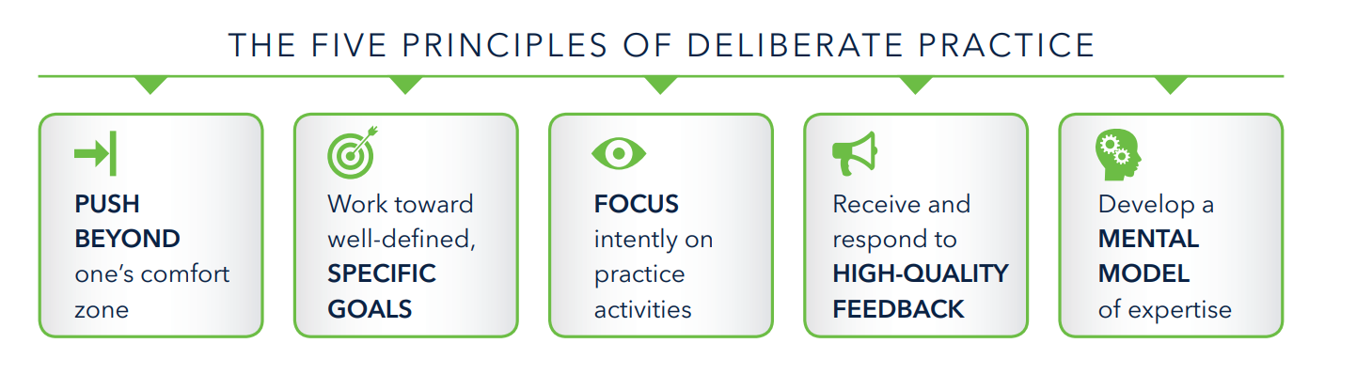
For more information read Deans For Impact, Practice with Purpose - https://deansforimpact.org/resources/practice-with-purpose/

Bibliography
Year 2, What and Why
Allen, R. and Sims, S., 2018. The Teacher Gap. 1st ed. Abingdon: Routledge.
Darling-Hammond, L. and Sykes, G., 2003. Wanted, A National Teacher Supply Policy for Education: The Right Way to Meet The "Highly Qualified Teacher" Challenge. education policy analysis archives, 11, p.5.Hanushek (2011:467)
Department for Education. 2020. Reporting Year 2019: School workforce in England. https://explore-education-statistics.service.gov.uk/find-statistics/school-workforce-in-england [Accessed 06 May 2021]
Department for Education. 2019. Teacher Recruitment and Retention Strategy https://assets.publishing.service.gov.uk/government/uploads/system/uploads/attachment_data/file/786856/DFE_Teacher_Retention_Strategy_Report.pdf [Accessed 06 May 2021]
EEF. 2019. Staff Deployment & Development. [online] Available at: <https://educationendowmentfoundation.org.uk/school-themes/staff-deployment-development/> [Accessed 22 May 2020].
Fletcher-Wood, H. (2018) Between novice and expert: complex tasks and intermediate learning. Available here: https://improvingteaching.co.uk/2018/03/11/between-novice-to-expert-complex-tasks-and-intermediate-learning/
Foster, D., 2019. Teacher Recruitment And Retention In England. [online] House of Commons Library. Available at: <https://commonslibrary.parliament.uk/research-briefings/cbp-7222/> [Accessed 22 May 2020].
Hanushek, E., 2011. The economic value of higher teacher quality. Economics of Education Review, 30(3), pp.466-479
Hollis, E (2018). Early career framework; what might this mean for recruitment and retention? Available here: https://edexec.co.uk/early-career-framework-what-might-this-mean-for-recruitment-and-retention/
Kraft, M.A. & Blazer, D. (2018). Taking Teacher Coaching To Scale. Education Next. 18, No. 4. Available at: https://www.educationnext.org/taking-teacher-coaching-to-scale-can-personalized-training-become-standard-practice/ [Accessed 06 May 2021]
Kraft M.A. & Papay J.P. (2014) Can Professional Environments in Schools Promote Teacher Development? Explaining Heterogeneity in Returns to Teaching Experience. Educational Effectiveness and Policy Analysis. 2014;36 (4) :476-500. Available at: https://scholar.harvard.edu/files/mkraft/files/kraft_papay_-_prof_env_teacher_development_eepa_full.pdf [Accessed 06 May 2021]
Papay J.P. & Kraft M.A. (2016) The Myth of the Teacher Performance Plateau. Educational Leadership. 2016;73 (May) :36-42. Available at: https://scholar.harvard.edu/files/mkraft/files/papay_and_kraft_-_ed_leadership_-_may_2016.pdf [Accessed 06 May 2021]
Mccrea, P. (2018). Expert Teaching What is it, and how might we develop it? Available at:
https://www.researchgate.net/publication/324759008_Expert_Teaching_What_is_it_and_how_might_we_develop_it_Peps_Mccrea/download
Sharples, J., Albers, B. and Fraser, S., (2018) ‘Putting Evidence to Work’ [online] Dera.ioe.ac.uk. Available at: <https://dera.ioe.ac.uk/31088/1/EEF-Implementation-Guidance-Report.pdf> [Accessed 13 June 2020].
Timperley, H. (2008). Teacher professional learning and development. Educational Practices (18). International Academy of Education
Science of Learning
Agarwal, P. K., & Roediger III, H. L. (2018). Lessons for learning: How cognitive psychology informs classroom practice. Phi Delta Kappan, 100(4), 8-12.PDF,
Berliner,D. (1988). The development of expertise in pedagogy. American Association of Colleges for Teacher Education, Washington, D.C. Available at: https://files.eric.ed.gov/fulltext/ED298122.pdf
Clark, R., Kirschner, P. & Sweller, J. (2012). Putting students on the path to learning: The case for fully guided instruction. American Educator, 36(1): 6-11. Available at: https://files.eric.ed.gov/fulltext/EJ971752.pdf
Clarridge, P.B. & Berliner, D.C. (1991) Perceptions of student behaviour as a function of expertise. Journal of Classroom Interaction, 26, p. 1–8.
Deans for Impact (2017) Practice with Purpose: The Emerging Science of Teacher Expertise. Available at: https://goo.gl/jh8N4Z
Deans for Impact (2018). Building Blocks. [online] Available at: https://deansforimpact.org/wp-content/uploads/2017/11/Building-Blocks_Framework.pdf [Accessed 22 May 2020].
EEF. 2018. Metacognition and self-regulated learning. [online] Available at: https://educationendowmentfoundation.org.uk/tools/guidance-reports/metacognition-and-self-regulated-learning/ [Accessed 06 May 2021].
Findell, C.R. (2009) What Differentiates Expert Teachers from Others? The Journal of Education, 188(2), p. 11–24.
Furst, E. (2018). From neuroscience to the classroom. ResearchEd 1, no. 2 (September): 30-33
Furst, E. (2018). Learning in the Brain. https://sites.google.com/view/efratfurst/learning-in-the-brain [Accessed 06 May 2021]
Loewenberg Ball, D., Thames, M. and Phelps, G., 2008. Content Knowledge for Teaching. Journal of Teacher Education, 59(5), pp.389-407.
Roediger, H. & Karpicke, J. (2006) “Test-Enhanced Learning: Taking Memory Tests Improves Long-Term Retention.” Psychological Science 17, no. 3 (March 2006): 249–55.
Roediger, H.L. III, Nestojko, J.F. & Smith, N. (2019). Strategies to improve learning and retention during training. In M.D. Mathews & D.M. Schnyer (Eds.), The Cognitive and Behavioral Neuroscience of Human Performance in Extreme Settings. New York: Oxford University Press. PDF
Schempp, P., Tan, S. & McCullick, B. (2002) The practices of expert teachers. Teaching and Learning, 23(1), p. 99–106.
Sternberg, R.J. & Horvath, J.A. (1995) A prototype view of expert teaching. Educational Researcher, 24(6), p. 9–17.
Sweller, J. (1988). Cognitive load during problem solving: Effects on learning. Cognitive Science, 12(2), 257-285
Westerman, D.A. (1991) Expert and Novice Teacher Decision Making. Journal of Teacher Education, 42(4) p. 292–305.
Deans for Impact (2015) The Science of Learning. Available at: https://goo.gl/VpUw1y
Willingham, D., 2009. Why Don't Students Like School?. San Francisco, CA: Jossey-Bass.
Wolff, C.E., Jarodzka, H. & Boshuizen, H.P.A. (2017) See and tell: Differences between expert and novice teachers’ interpretations of problematic classroom management events. Teaching and Teacher Education, 66, p. 295–308
Teacher change
Hobbiss, M., Sims, S., & Allen, R. (2020). Habit formation limits growth in teacher effectiveness: A review of converging evidence from neuroscience and social science. Review of Education, rev3.3226.
Hood, M. (2016). Beyond the Plateau: The case for an institute of advanced teaching. IPPR. Available at: https://www.ippr.org/files/publications/pdf/beyond-the-plateau_July2016.pdf [Accessed 06 May 2021]
Lally, P., Van Jaarsveld, C. H. M., Potts, H. W. W., & Wardle, J. (2010). How are habits formed? Modelling habit formation in the real word. European Journal of Social Psychology, 40, 998–1009. Available at: https://www.researchgate.net/publication/32898894_How_are_habits_formed_Modeling_habit_formation_in_the_real_world [Accessed 06 May 2021]
Adapting the model
Hill, Heather & Charalambous, Charalambos & Kraft, Matthew. (2012). When Rater Reliability Is Not Enough: Teacher Observation Systems and a Case for the Generalizability Study. Educational Researcher. 41. 56-64. Available at https://www.researchgate.net/publication/254088727_When_Rater_Reliability_Is_Not_Enough_Teacher_Observation_Systems_and_a_Case_for_the_Generalizability_Study [Accessed 06 May 2021]
Schmidt H.G., Rikers R.M. How expertise develops in medicine: knowledge encapsulation and illness script formation. Medical Education. 2007 Dec;41(12):1133-9. Link
Instructional Coaching
Berliner, D. (2001). Learning about and learning from expert teachers. International Journal of Educational Research 35, pp.463–482.
Deans for Impact (2017) Practice with Purpose: The Emerging Science of Teacher Expertise. Available at: https://goo.gl/jh8N4Z
Kraft M.A., Blazar D., Hogan D. The Effect of Teacher Coaching on Instruction and Achievement: A Meta-Analysis of the Causal Evidence. Review of Educational Research [Internet]. 2018;88 (4) :547-588.
Implementation
EEF. 2019. Putting Evidence to Work: A School’s Guide to Implementation. [online] Available at: https://educationendowmentfoundation.org.uk/public/files/Publications/Implementation/EEF_Implementation_Guidance_Report_2019.pdf [Accessed 06 May 2021].
Glei, J., 2013. Maximize Your Potential: Grow Your Expertise, Take Bold Risks Build An Incredible Career. 1st ed. Amazon publishing

